1. Agenda:
   1. Starting more than one instance of the consumer MS.
2. As we have already assigned the Email Notification Consumer MS to a group, now we can start up more than one instance of this.
3. 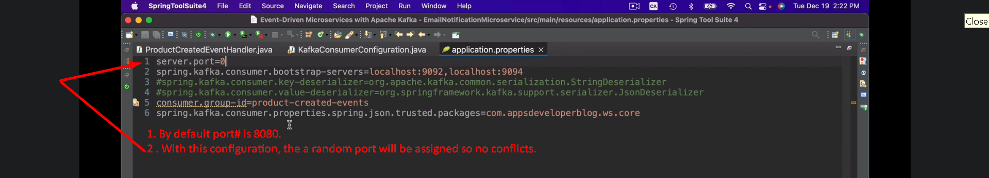
4. 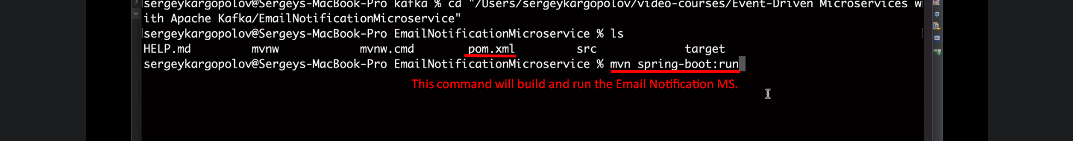  
   Like this start two more instances. So total 3 instances.   
   They will consume the msg from the same topic.